**Applying evolutionary principles to optimize control of metastatic castrate-resistant prostate cancer**

Jingsong Zhang1, Jessica J. Cunningham2, Joel S. Brown2,3 and Robert A. Gatenby2,4,*

1Department of Genitourinary Oncology, Moffitt Cancer Center & Research Institute, Tampa, Florida 33612, USA. 2Department of Integrated Mathematical Oncology, Moffitt Cancer Center & Research Institute, Tampa, Florida 33612, USA. 3 Department of Biological Sciences, University of Illinois at Chicago, Chicago, Illinois, 60607, USA. 4Department of Diagnostic Imaging and Interventional Radiology, Moffitt Cancer Center & Research Institute, Tampa, Florida, 33612, USA.

*correspondence:

Robert A. Gatenby

Moffitt Cancer Center

12902 Magnolia Dr

Tampa, FL 33612

[Robert.Gatenby@moffitt.org](mailto:Robert.Gatenby@moffitt.org)

**Prostate cancer cells frequently evolve resistance to androgen deprivation therapy (ADT) through increased expression of CYP17A1, which permits testosterone auto-synthesis. Abiraterone inhibits CYP17A1 activity and is commonly used to treat metastatic castrate-resistant prostate cancer (mCRPC). Consistent with conventional oncology practice, abiraterone is typically administered at maximum tolerated dose (MTD) until progression. We have previously demonstrated theoretically and experimentally that MTD treatment both selects for resistant phenotypes and accelerates their proliferation by eliminating competitors. A simple mathematical model of intratumoral evolutionary dynamics in mCRPC defines three competing subpopulations: (i) TP cells express CYP17A1 and produce testosterone; (ii) T+ cells require exogenous androgen; and (iii) T- cells are androgen-independent and abiraterone-resistant. Computer simulations demonstrate T+ cells, although suppressed by ADT, can re-emerge as a “cheater” population consuming testosterone produced as a “public good” by TP cells. Treatment simulations found administration and withdrawal of abiraterone, when guided by intratumoral evolutionary dynamics, produces population cycles that can maintain prolonged tumor control. Model predictions were assessed in a pilot trial of 10 men with mCRPC who received adaptive dosing of abiraterone. Mean follow-up time is 15.6 months. Pre-treatment biopsies support model predictions of “cheating” dynamics. Cycles of response and regrowth similar to model simulations are observed with cycle lengths varying from 3 months to > 1 year. Nine subjects remain on treatment. Mean time to progression has not been reached but significantly exceeds the best reported time. Adaptive drug administration reduced the cumulative abiraterone dose to 40% of standard of care.**

While evolution of resistance frequently leads to treatment failure, explicit incorporation of intratumoral Darwinian dynamics into cancer therapeutic trials is rare1. Current practices are founded upon the decades-old assumption that optimal therapy requires killing the largest possible number of tumor cells. This is typically achieved by administering drugs at maximum tolerated dose (MTD) until progression. We propose the goal of effecting maximum tumor cell death, while intuitively appealing, is evolutionarily unwise. In fact, by strongly selecting for resistant phenotypes an eliminating all potential competitors, it maximally promotes treatment failure. These Darwinian dynamics are well recognized and termed “competitive release”2.

An alternative treatment strategy, when cure is not a achievable outcome, relies on evolutionary principles to maintain tumor control rather than attempting eradication 3-6. Each tumor is viewed as a collection of competing subpopulations 7 and therapy is applied selectively to maximally suppress proliferation off resistant phenotypes that leads to treatment failure. Here we focus on “adaptive therapy”, which exploits the evolutionary cost of resistance such as synthesis, maintenance and operation of molecular machinery to defeat the toxic effects of treatment. The benefit of this expense exceeds its cost during therapy. However, in the absence of treatment particularly in the resource-limited environment of a tumor microenvironment, treatment-sensitive cells are typically fitter8. By maintaining a residual population of treatment-sensitive cells and then withdrawing therapy, this strategy drives a cycle of regression and progression. However, since tumor growth occurs in the absence of therapy, the Darwinian dynamics favor proliferation of treatment-sensitive cells because of their fitness advantage thus suppressing growth of the resistant phenotype.

Developed initially through mathematical models 9,10, adaptive therapy has successfully controlled breast and ovarian cancers, often indefinitely, in pre-clinical experiments 2,3,11. Translating evolution-based strategies to clinical treatment, initially required identifying intratumoral subpopulations – in this case prostate - cancer based on their interactions with critical treatment parameter - in this case testosterone. We conceptualized and modeled the intratumoral evolutionary dynamics of these populations as well as perturbations imposed by various treatment strategies.

Most prostate cancers are cured with local therapy. However, once metastatic, cure is not possible despite multiple available therapies. As most prostate cancer cells are initially dependent on exogenous testosterone, first line treatment is androgen deprivation therapy (ADT). Most prostate cancers secrete a serine protease, prostate specific antigen (PSA), which is a transcriptional target of the androgen receptor and serves as serum biomarker for response to therapy. After ADT, PSA values typically drop and remain low for ~2 years until resistance develops and the PSA levels begin to rise - a clinical state termed “metastatic castrate-resistant prostate cancer (mCRPC)”.

In about 60% of mCRPC patients, the main mechanism of ADT resistance is increased expression of CYP17A1, a key enzyme for androgen synthesis. This generates an autocrine loop that replenishes intratumoral testosterone concentrations to drive mCRPC progression. Abiraterone acetate, a CYP17A inhibitor has been shown to reduce PSA, prolong progression-free survival and overall survival for patients with mCRPC. However, the response to abiraterone is brief and time to PSA progression ranges from 5.8 (post docetaxel) to 11.1 months (pre docetaxel) 12-14.

As clinical data regarding cellular heterogeneity of mCRPC are sparse, we used a minimalist modeling approach that defined cell phenotypes solely by their interactions with testosterone: (i) TP cells express AR and high levels of CYP17A, and thus produce testosterone; (ii) T+ cells express AR but require exogenous androgen; and (iii) T- cells are androgen-independent and resistant to abiraterone.

We model mCRPC as a game where both the abundance and the identity of tumor cells determine fitness. Lotka-Volterra equations describe the population dynamics and interactions between populations

. $\frac{{dx}_{i}}{dt}=r_{i}x_{i}\left(1-\frac{\sum_{i=1}^{3}{\sum_{j=1}^{3}{a_{ijx_{i}}}}}{K_{i}}\right)$

Where *xi* is each population, *Ki* is the carrying capacity and *ri* is the intrinsic growth rate. The interactions coefficients, *aij*, describe the effect of cell type *j* on the population growth rate of type *i*. The effect of a cell type on itself is scaled to *aii = 1* meaning cells of a type are interchangeable. The interaction coefficients can be presented as a matrix. To place bounds on the inter-type coefficients (off-diagonal elements of *aij*; *i ≠j*) we determined which values must likely be larger than others based on data available from each patient. Because cell types largely compete with each other and different cell types exhibit various forms of niche partitioning all elements were set to between 0 and -1.

Based on the near universal initial response to ADT, our models assumed that, in the presence of exogenous testosterone, T+ cells are fitter than TP or T- cells. It is likely that TP cells have the increased costs of testosterone production; and T- cells, the constitutive upregulation of androgen signaling pathways. However, given tumor heterogeneity, small subpopulations of treatment–resistant phenotypes (TP and T- cells) are assumed to be present. Continuous ADT greatly decreases or completely eliminates the T+ population, but allows proliferation of TP and T- populations, which lead to tumor recurrence. However, if there is a surviving T+ population at recurrence, increases in interstitial testosterone produced via TP cells represents a “public good” and the T+ cells can proliferate. This “cheating” dynamic (*i.e.*, benefitting from testosterone without incurring costs of its synthesis) is a well-established phenomenon in evolution 15,16.

The evolutionary dynamics of abiraterone therapy in mCRPC is largely governed by the relative fitness of the TP and T- populations. We assume this will be different in each patient. In the absence of explicit data, we employ an inverse problem assumption – if the PSA drops significant after the initial dose of abiraterone, the TP (+/- T+) cells are dominant and, therefore, fitter than T- cells (in evolutionary game theory, fitness and proliferation are equivalent). If there is no significant response to abiraterone, the fitness of T- is assumed to be greater than TP.

Model simulations demonstrate standard, continuous application of abiraterone at MTD will eliminate the TP cells as well as any associated T+ cheaters and strongly select for the T- phenotype leading to clinical progression (Fig. 1). However, the models demonstrate (Figure 1)that, if the fitness of TP and T+ cells in the absence of therapy are greater than that of the T- cells, an evolutionary strategy can result in prolonged tumor control (Fig. 2).Here a strategy in which abiraterone is withdrawn when TP cells (with or without T+ cheaters) still remain present will result in tumor regrowth but, because of their relative fitness advantage in the absence of therapy, the tumor populations that recur will be nearly identical to those that were present at the start of therapy (Fig. 2). The models demonstrate that this adaptive strategy can maintain prolonged tumor control through multiple (up to ~20) on/off cycles

Notably, based on the slope of the PSA curve during progression while on ADT, as well as the initial decline in PSA levels following the first dose of abiraterone, this model can then be parameterized in individual patients. This allows a lockstep approach where data that emerge from the clinical trial inform the models and the proper course of adaptive abiraterone therapy. In its first iteration both the mathematical model and adaptive therapy algorithm are simple as they relies only on serum PSA levels. However, with addition clinical data parameters there should be marked improvements in both the model and clinical outcomes.

We examined model predictions in an IRB-approved pilot clinical protocol in which abiraterone is administered through an adaptive therapy algorithm. Full details of the protocol are provided in the Extended Data. Prior studies had investigated intermittent androgen deprivation but in all cases treatment changes were timed arbitrarily and not explicitly linked to underlying evolutionary dynamics. In brief, patients receiving abiraterone as standard of care for mCRPC were eligible for the trial. Serum PSA was determined every 4 weeks and radiographic evaluation with bone scan and abdomen/pelvis CT scans were performed every 3 months. If the response to the initial abiraterone dose resulted in a PSA decrease of >50% of baseline, informed consent was obtained and treatment was discontinued until the PSA returned to its pre-treatment level. Each patient was treated using this on/off cycle of abiraterone as long as the PSA continued to cycle in response to therapy. Treatment was discontinued if PSA increased on abiraterone or in the event of radiographic progression. To be clear, prior studies have investigated intermittent androgen deprivation therapy (Tsai et al (Urology 2013, 82;327-333). However, all of these trials used arbitrary treatment schedules with no attempt to link changes in therapy to intra-tumoral evolutionary dynamics.

In the first 10 subjects, the tumor remained responsive to abiraterone when PSA reached its pre-treatment levels after initial treatment withdrawal. Notably, immunohistochemical (IHC) analyses of testosterone and CYP17A1 expression in lymph nodes metastases from 3 patients revealed co-localization of TP and T+ cell (Fig. 3) consistent with model-predictions of cheating dynamics

Cycles of response and progression were observed in all of the patients (Figure 2) with cycle length ranging from 3 months to > 1 year. Because of this variation, some subjects have undergone 6 cycles of therapy after 18 months on trial while one individual is only on his 2nd cycle after more than 2 years. Nine of the 10 patients remain on trial (Figure 4) with mean follow-up time of 15.6 months. Median time to PSA progression has not been reached but is already significantly greater than the historic control of 11.1 months (p<0.02). Furthermore, median cumulative dose of abiraterone in the study cohort is currently 40% of standard of care dosing.

Estimating the evolutionary and ecological dynamics of tumor sensitive and resistant subpopulations during cancer therapy is challenging, but likely necessary to optimize outcomes. Here we investigate the complex tumor system using a standard ecological strategy in which we design and apply a perturbation and then measure the outcomes. As predicted in our mathematical models, evolution-based administration and withdrawal of therapy in mCRPC elicited a complex, diverse, and highly patient-specific response. Nevertheless, a simple model based on the interactions of prostate cancer cell phenotypes with their critical growth factor (testosterone) appears to provide important, often unexpected, insights into the underlying Dawinian dynamics during abiraterone therapy that may increase progression free survival while lowering drug doses.

However, these results should be viewed with caution. Our model rests on the assumption that t key subpopulations compete with each other and, therefore, have some degree of spatial interactions. This assumption appears to hold mCRPC but that may reflect optimal conditions in which the tumor burden is relatively small and the tumor populations have recently passed through an evolutionary bottleneck imposed by ADT. Spatially-explicit models with application of multiple drugs targeting different subpopulations will be necessary may be necessary in larger, regionally-heterogenous tumors.

Finally, our results highlight the dearth of clinical data relevant to intratumoral evolution during therapy. To that end, our study has produced a novel clinical data set that can begin a process of optimization to further define and exploit intratumoral evolution during therapy. Additional diagnostic tools such as circulating tumor cells, circulating DNA, and sophisticated analysis of clinical imaging tools may help to better identify the ecological and evolutionary changes in tumors during therapy to refine mathematical models and further improve patient outcomes.

**References**

1 Aktipis, C. A., Kwan, V. S., Johnson, K. A., Neuberg, S. L. & Maley, C. C. Overlooking evolution: a systematic analysis of cancer relapse and therapeutic resistance research. *PLoS One* **6**, e26100, doi:10.1371/journal.pone.0026100 (2011).

2 Enriquez-Navas, P. M., Wojtkowiak, J. W. & Gatenby, R. A. Application of Evolutionary Principles to Cancer Therapy. *Cancer Res* **75**, 4675-4680, doi:10.1158/0008-5472.CAN-15-1337 (2015).

3 Gatenby, R. A., Silva, A. S., Gillies, R. J. & Frieden, B. R. Adaptive therapy. *Cancer Res* **69**, 4894-4903, doi:10.1158/0008-5472.can-08-3658 (2009).

4 gatenby RA, B. J., Vincent T. Lessons from Applied Ecology: Cancer Control Using an Evolutionary Double Bind. *Cancer Res* **69**, 7499-7502, doi:10.1158/0008-5472.CAN-09-1354 (2009).

5 Gatenby, R. A. A change of strategy in the war on cancer. *Nature* **459**, 508-509, doi:10.1038/459508a (2009).

6 Gatenby, R. Perspective: Finding cancer's first principles. *Nature* **491**, S55 (2012).

7 Lloyd MC, C. J., Bui MM, Gillies RJ, Brown JS, Gatenby RA. Darwinian dynamics of intratumoral heterogeneity: random mutations or variable selection forces? *Cancer Research* **In press.** (2016).

8 Kam, Y. *et al.* Sweat but no gain: inhibiting proliferation of multidrug resistant cancer cells with "ersatzdroges". *Int J Cancer* **136**, E188-196, doi:10.1002/ijc.29158 (2015).

9 Silva, A. S. *et al.* Evolutionary approaches to prolong progression-free survival in breast cancer. *Cancer Res* **72**, 6362-6370, doi:10.1158/0008-5472.can-12-2235 (2012).

10 Gatenby, R. A. & Frieden, B. R. Inducing catastrophe in malignant growth. *Math Med Biol* **25**, 267-283, doi:10.1093/imammb/dqn014 (2008).

11 Enriquez-Navas, P. M. *et al.* Exploiting evolutionary principles to prolong tumor control in preclinical models of breast cancer. *Sci Transl Med* **8**, 327ra324, doi:10.1126/scitranslmed.aad7842 (2016).

12 Antonarakis, E. S. Abiraterone acetate for prostate cancer: a new era of hormonal therapies. *Asian J Androl* **13**, 663-664, doi:10.1038/aja.2011.92 (2011).

13 Ryan, C. J. *et al.* Abiraterone in metastatic prostate cancer without previous chemotherapy. *N Engl J Med* **368**, 138-148, doi:10.1056/NEJMoa1209096 (2013).

14 Reid, A. H. *et al.* Significant and sustained antitumor activity in post-docetaxel, castration-resistant prostate cancer with the CYP17 inhibitor abiraterone acetate. *J Clin Oncol* **28**, 1489-1495, doi:10.1200/JCO.2009.24.6819 (2010).

15 Scheuring, I. Diffusive public goods and coexistence of cooperators and cheaters on a 1D lattice. *PLoS One* **9**, e100769, doi:10.1371/journal.pone.0100769 (2014).

16 Waite, A. J. & Shou, W. Adaptation to a new environment allows cooperators to purge cheaters stochastically. *Proc Natl Acad Sci U S A* **109**, 19079-19086, doi:10.1073/pnas.1210190109 (2012).

**Acknowledgements**.

This work was supported by the James S. McDonnell Foundation grant, “Cancer therapy: Perturbing a complex adaptive system,” NIH/National Cancer Institute (NCI) R01CA170595, Application of Evolutionary Principles to Maintain Cancer Control (PQ21), and NIH/NCI U54CA143970-05 [Physical Science Oncology Network (PSON)] “Cancer as a complex adaptive system.” This work has also been supported in part by the Clinical Trials Core Facility at the H. Lee Moffitt Cancer Center and Research Institute, an NCI-designated Comprehensive Cancer Center (P30-CA076292). We thank Robert Gillies and John Cleveland for critical review of the manuscript,

**Author Contributions**

JZ conducted the clinical trial, JR, JB, and RG developed the mathematical models of intratumoral evolutionary dynamics, JR performed the simulations. All authors contributed to the writing of the manuscript

**Author Information** Reprints and permissions information is available at www.nature.com/reprints. The authors declare no competing financial interests. Readers are welcome to comment on the online version of this article at [www.nature.com/nature](http://www.nature.com/nature). Correspondence and requests for materials should be addressed to R.A.G. ([Robert.Gatenby@moffitt.org](mailto:Robert.Gatenby@moffitt.org)).

**Figures and Legends**

Figure 1 Computer simulations of mCRPC growth during conventional and adaptive application of abiraterone. The top panel is a computer simulation of conventional abiraterone treatment at MTD until progression. This strategy selects for the resistant subclones and eliminates competitors to accelerate progression – a well-recognized evolutionary phenomenon termed “competitive release.” In the lower panel, we model a strategy in which therapy-sensitive cells are preserved by withdrawing abiraterone when the PSA reaches 0.5 of its pre-treatment value. This permits the tumor to regrow but, in the absence of therapy, the sensitive cells are fitter and thus remain the dominant population. This permits retreatment with abiraterone to maintain tumor control over multiple cycles. Note , however, that at PSA trough of each cyle there is a small increase of the T- cells. This permits a slow but monotonic increase in the population of resistant cells that will eventually lead to treatment failure. The number of cycles until failure is dependent on the size of the original T- population and their growth rate. Model predictions suggest the number of observed cycle will range from 2 to 20. Importantly the model predicts cycle length can vary depending on initial conditions (i.e., the pretreatment size of the subpopulations) and the relative fitness difference values of each phenotype.



**Figure 2**  Computer simulations of mCRPC growth during conventional and adaptive application of abiraterone. In the top row, we model a strategy in which therapy-sensitive cells are preserved by withdrawing abiraterone when the PSA reaches 0.5 of its pre-treatment value. This permits the tumor to regrow but, in the absence of therapy, the sensitive cells are fitter and thus remain the dominant population. This permits retreatment with abiraterone to maintain tumor control over multiple cycles. Note , however, that at PSA trough of each cyle there is a small increase of the T- cells. This permits a slow but monotonic increase in the population of resistant cells that will eventually lead to treatment failure. The number of cycles until failure is dependent on the size of the original T- population and their growth rate. Model predictions suggest the number of observed cycle will range from 2 to 20. Importantly the model predicts cycle length can vary depending on initial conditions (i.e., the pretreatment size of the subpopulations) and the relative fitness difference values of each phenotype.

In the bottom row, the actual PSA fluctuations in 2 patients with associated abiraterone administration. Clearly, incorporation of evolutionary dynamics into treatment elicits a wide range of patient-specific outcomes. In one patient, the PSA has not changed following withdrawal of therapy for over 2 years. In the others, cycles as predicted by the model are observed but the cycle length varies from about 3 months to over 1 year**.**

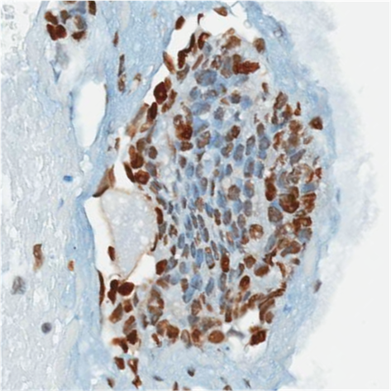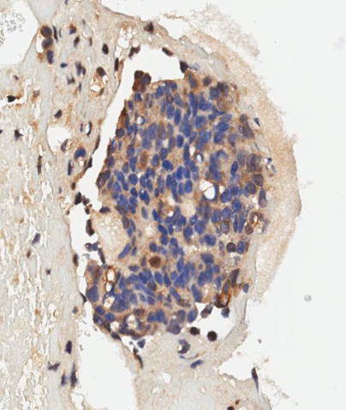

**Figure 3** TP and T+ cells are manifest in mCRPC tumours following ADT. Immunohistochemical analyses of androgen receptor (AR) and CYP17A1 expression in mCRPC lymph node metastasis needle biopsy from a subject in the current clinical trial. *Left panel*: Immunohistochemical (IHC) analyses androgen receptor (AR) expression shows a significant population of T+ cells under continuous ADT. *Right panel*: CYP17A1 and AR show that the population of TP cells that express CYP17A1 and produce testosterone to support the population of T+ cells.



**Figure 4** Status of the first 10 patients in the mCRPC adaptive therapy trial. Black in the bar indicates time during which abiraterone was withheld and Red is time during which therapy was administered. 9 of the patients remain on study with controlled tumor. Mean follow up time is 15.6 months. Mean progression free survival has not been reached but already exceeds the best reported PFS (11.1 months). Because of the adaptive application of treatment, the mean cumulative dose for the cohort is only 38% of standard of care.

**Figure 1**

**Figure 2**



Figure 2: Top row. Standard of care, as shows with PSA values highlighted in red continuously after initiation of Abiraterone. Bottom row: Adaptive therapy, again where red highlights when the patient is on abiraterone.

Left column is where T+ cells are most fit as defined by the matrix game. The right column is where TP is most fit as defined by the matrix game.

**Figure 3**

Macintosh HD:Users:cunningham:Dropbox:ProstateCancerModel:TrialAnalysis:filename.eps

Macintosh HD:Users:cunningham:Dropbox:ProstateCancerModel:TrialAnalysis:filename.epsMacintosh HD:Users:cunningham:Dropbox:ProstateCancerModel:TrialAnalysis:FastAndSlowOnlyNormalized.eps

Figure 3: Top: Trial patient PSA aligned to first day of abiraterone and normalized to baseline PSA. Bottom left is patient 1001, exhibiting fast cycles, would fit into the T+ dominant tumor predicted by model. Bottom right is patient 1007, exhibiting slow cycles, that would fit with the TP dominant tumor predicted by models.

**Figure 4**

**Figure 5**

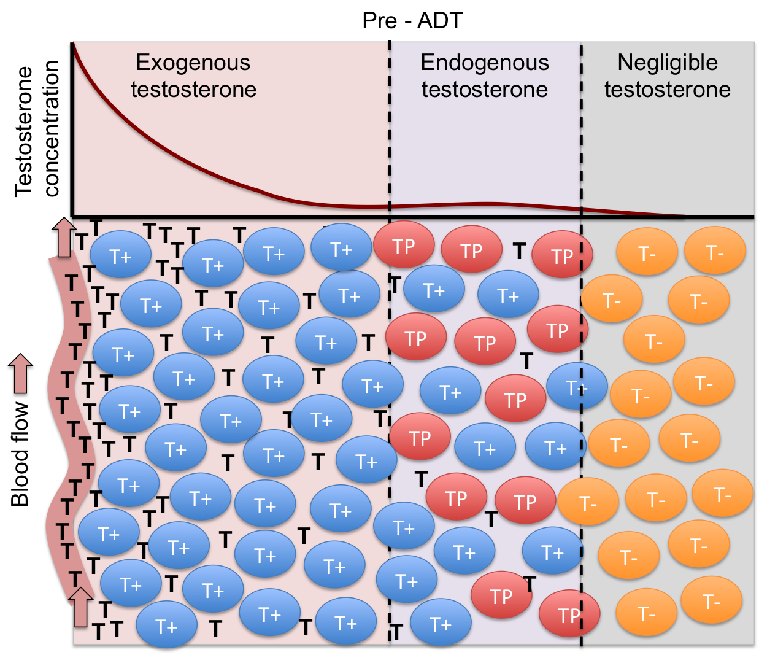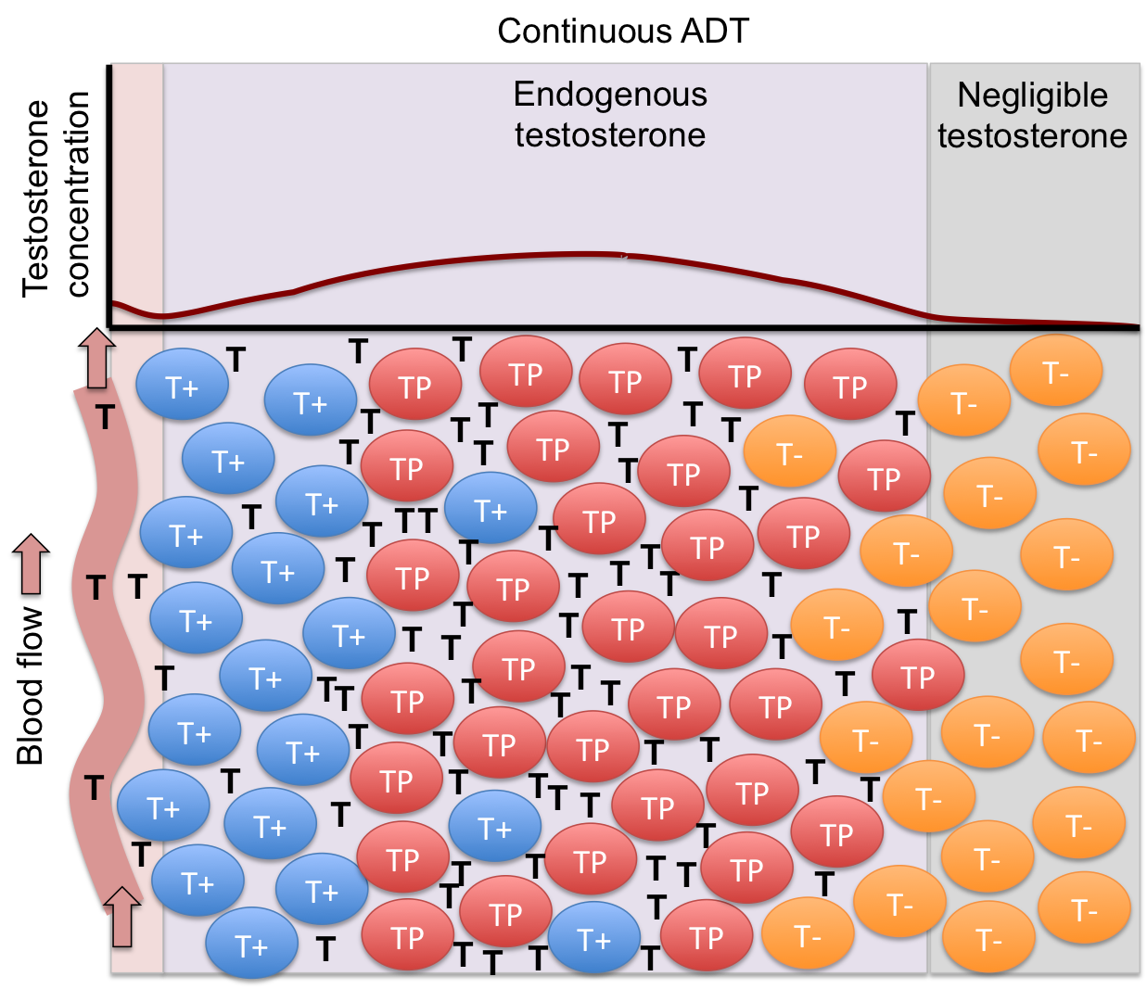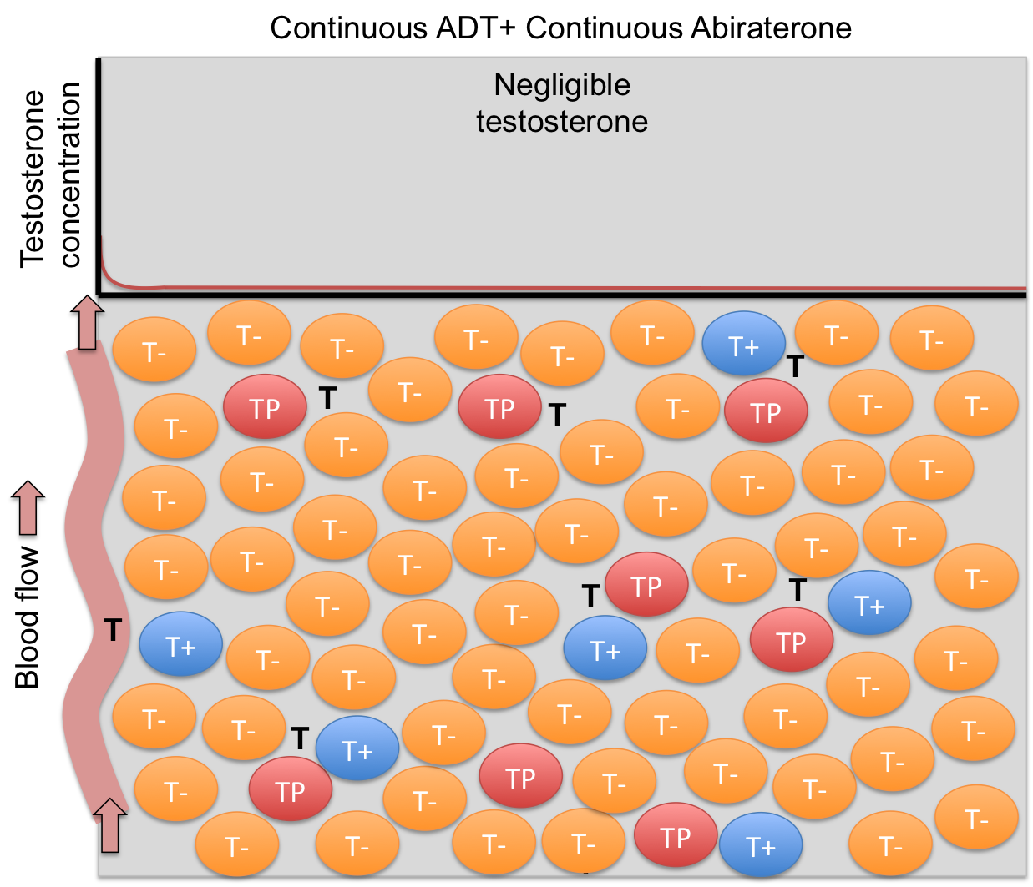

**Supplemental Material**

**Clinical Trial**

Study Objectives and Endpoints

*Primary objective:*

Describe the percentage of abiraterone responsive (defined as 50% decline of PSA) blacks and non-blacks who remain to be responsive to abiraterone after completing 2 adaptive treatment cycles

*Secondary objectives*:

1. Describe the rPFS in blacks and non-blacks undergoing adaptive abiraterone therapy

2. Describe the time to ECOG performance status deterioration in blacks and non-blacks undergoing adaptive abiraterone therapy

*Exploratory objectives/correlative studies:*

1. Detect the intra-tumor heterogeneity of AR IHC stains on FFPE blocks of primary tumors

2. Measure the changes in CTC numbers, the relative mRNA abundances of AR-FL, AR-V7 and ARV567ES in CTC before and after abiraterone therapy

3. Develop a mathematical model for adaptive abiraterone therapy)

4. Assess the CYP17 (rs743572) polymorphism among study subjects

5. Identify patient-, protocol-, or systemic barriers for study enrollment

*Endpoints*

Primary endpoint

PSA response rate (defined as 50% decline of pre abiraterone PSA) at cycle 2

*Secondary endpoints*:

1. Median rPFS

2. Median time to ECOG performance status deterioration

Screening and Eligibility

*Inclusion criteria: patients must meet all of the following criteria*

1. .Histologically or cytologically confirmed adenocarcinoma of the prostate (the availability archival prostate tumor sample is preferred not required)

2. .Asymptomatic or minimally symptomatic metastatic CRPC patients on abiraterone and achieved at least 50% decline of their pre-treatment PSA

3. .Performance status ECOG 0-2

4. Adequate organ function:

Serum alanine aminotransferase (ALT) or aspirate aminotransferase (AST) must be < 2.5 x upper limit of normal (ULN), total bilirubin < 1.5 X ULN, estimated creatinine clearance must be >40 mL/min, absolute neutrophil count (ANC) > 1500/l, hemoglobin above 9 g/dl, platelet count > 100,000/l

5. Stable medical condition, including the absence of acute exacerbations of chronic illnesses, serious infections or major surgery within 28 days prior to study enrollment

6. Prior surgical castration or concurrent use of GnRH analogue (i.e. medical castration) with testosterone at screening <50 ng/dL.

7. Life expectancy of 12 months or more

8. Ability to give written informed consent

*Exclusion criteria: any of the following is a criterion for exclusion from the study*

1. Except GnRH analogue therapy, any other therapies for prostate cancer (excluding bisphosphonate and denosumab) must be discontinued 3 weeks before the first dose of study drugs.

2. Prior treatments with TAK-700/Orteronel, ketoconazole, enzalutamide or docetaxel (up to 6 cycles of docetaxel given in the non CRPC setting is allowed). Prior treatment with Sipuleucel-T is allowed.

3. Exposure to radioisotope therapy (samarium 153 or radium 223) within 8 weeks of receiving the first dose of study drugs; exposure to external beam radiation within 4 weeks of start of receiving the first dose of study drugs.

4. Documented central nervous system metastases or liver metastasis

5. Treatment with any investigational compound within 30 days prior to the first dose of study drugs

6. Diagnosis or treatment for another systemic malignancy within 2 years before the first dose of study drugs, or previously diagnosed with another malignancy & have any evidence of residual disease. Patients with non-melanoma skin cancer or carcinoma in situ of any type are not excluded if they have undergone complete resection.

7. Uncontrolled hypertension despite appropriate medical therapy (blood pressure of greater than 160 mmHg systolic and 90 mmHg diastolic at 2 separate measurements no more than 60 minutes apart during the Screening period). Note: Patients may be rescreened after adjustments of antihypertensive medications

8. Unstable symptomatic ischemic heart disease, ongoing arrhythmias of Grade > 2 (NCI CTCAE, version 4.03), New York Association Class III or IV heart failure

9. Known human immunodeficiency virus (HIV) infection, active chronic hepatitis B or C not contained with anti-viral therapy, life threatening illness unrelated to cancer, or any serious medical or psychiatric illness that could, in investigator’s opinion, potentially interfere with participation in this study.

10. Known GI disease or GI procedure that could interfere with the GI absorption or tolerance of study drugs, including difficulty swallowing tables.

11. Subjects with delayed healing of wounds, ulcers, and/or bone fractures

12. Inability to comply with protocol requirements

Investigational Plan

Subjects will be consented and pre-screened if they are starting abiraterone for their mCRPC as standard of care. One tube of blood will be collected for genomic DNA extraction and assessment of the CYP17 rs743572 polymorphism. A baseline bone scan, CT abdomen and pelvis will need to be performed within 4 weeks of starting abiraterone. Only subjects with 50% or higher decline of their PSA and meet the eligibility and exclusion criteria will be enrolled.

Each subject’s PSA and scans immediately prior to starting abiraterone therapy will be considered his baseline PSA and scans. Abiraterone will be stopped after study enrollment. This abiraterone stopping date will be counted as day 1, cycle 1 of the adaptive therapy cycle. Full dose Abiraterone (1000 mg by mouth daily) will be reinitiated when the PSA increases to the pre abiraterone baseline. Abiraterone will be stopped after subject’s PSA declines to 50% or more below its baseline.

Each time abiraterone is stopped, it will be defined as the start of a new adaptive therapy cycle. For patients who did not undergo surgical castration, GnRH analog treatment will be continued to maintain castrate level of serum testosterone. PSA will be monitored very 4 weeks. Subjects who cannot achieve a 50% decline of their baseline PSA after restarting abiraterone will remain on the study until they develop radiographic progression based on PCWG2 criteria [21]. Restaging bone scan, abdominal and pelvic CT will be performed every 3 months after starting day 1 of the adaptive abiraterone therapy. If the subject develops radiographic progression (progression scan) while being off abiraterone, abiraterone will need to be restarted. A confirmatory scan will need to be performed 8-9 weeks after restarting abiraterone. If there is no evidence of progression on the confirmatory scan compared to the progression scan, subjects will be taken off the study. Of note, patients in the AA301 and AA302 trials will not discontinue treatment until they develop radiographic disease progression. Patients will be followed until they develop radiographic progression or ECOG performance status deterioration, whichever comes later.

Visit schedule and assessments

Screening Assessments and all on study scheduled visits and assessments are outlined in Section 1.3. After discontinuing adaptive abiraterone therapy, subjects will be followed as clinically indicated until they develop ECOG performance status decline if this does not occur before radiographic progression.

Drug Administration

All subjects enrolled into this study have already been taking abiraterone 1000mg daily with empty stomach plus prednisone 5mg twice a day with food as standard of care. Abiraterone will be dispensed by the specialty pharmacy designated by patients’ insurance and needs to be taken around the same time every day. Subjects are required to bring their abiraterone bottles for pill count at each clinic visit even if they are off abiraterone per the adpative therapy protocol. Accurate records will be kept for abiraterone administration (including dispensing, dosing, and duration of treatment).

When abiraterone is discontinued per study protocol, prednisone tapering is not required. If prednisone tapering is chosen, the dose, frequency and length of prednisone tapering will need to be recorded in clinic visit notes.

*Toxicity Assessment and reporting of adverse events*

NCI CTAE version 4.03 will be used for toxicity assessment. Please refer to abiraterone FDA approval label for known toxicities of abiraterone.

Adverse events are reported in a routine manner at scheduled times during the study. Toxicity will be scored using CTCAE Version 4.03 for toxicity and adverse event reporting. A copy of the CTCAE Version 4.03 can be downloaded from the CTEP homepage (HTTP://CTEP.INFO.NIH.GOV). Any event that that is life threatening, requires inpatient hospitalization, results in persistent or significant disability or incapacity or results in death would be considered a serious adverse events (SAE). All serious, related adverse events (and unanticipated) will be reported and documented on forms as required by institutional guidelines and forwarded directly to the IRB in electronic version within 2-5 business days of becoming aware of the event

*Dose Reduction*

Dose reduction of abiraterone is allowed if subjects develop grade 3 or 4 adverse events (AE) related to abiraterone for more than 2 weeks.

Level 1 dose reduction is defined as 750 mg daily

Level 2 dose reduction is defined as 500 mg daily

Dose escalation to the full dose, i.e. 1000mg daily is allowed after these AEss are resolved. The lowest dose of abiraterone permitted is 500 mg daily. Subjects will be taken off study if abiraterone related grade 3 or 4 AEss do not resolve within 3 weeks after being off abiraterone.

Criteria for evaluation and Endpoint definition

*Measurability of Lesions*

Measurable disease:

1. Non lymph node Lesions that can be accurately measured in at least one dimension

(longest diameter to be recorded) by ≥ 1.0 cm with CT or MRI scans. All tumor measurements must be recorded in decimal fractions of centimeters.

2. Malignant lymph nodes are to be considered pathologically enlarged and measurable if it measures ≥ 1.5 cm in SHORT AXIS (greatest diameter perpendicular to the long axis of the lymph node) when assessed by scan

The defined measurability of lesions on CT scan is based on the assumption that CT slice thickness is 0.5 cm or less.

Non-measurable disease:

All other lesions (or sites of disease), including small lesions (longest diameter < 1.0 cm or pathologic lymph nodes with ≥ 1.0 cm to < 1.5 cm short axis), are considered non-measurable disease. Bone lesions, leptomeningeal disease, ascites, pleural/pericardial effusions, lymphangitis cutis/pulmonitis, and previously radiated lesions that have not progressed are considered non-measurable.

Progression Criteria

Given death and symptomatic progression are rare events in this patient population (AA302); rPFS was chosen as a secondary endpoint. Radiographic progression is defined by any of the following criteria:

1. Progression of measureable lesions per RECIST 1.1 criteria. Twenty percent increase in the sum of appropriate diameters of target measurable lesions over smallest sum observed (over pretreatment baseline if no decrease during therapy) using the same imaging techniques as baseline, as well as an absolute increase of at least 0.5 cm.

2. Progression on bone scan is defined as 2 or more new lesions on radionuclide bone scans. Should two or more new bone lesions be evident at the first assessment on treatment (Month 3), two or more additional new lesions must be evident on a confirmatory assessment at least 8 weeks or later (at investigator’s discretion). This confirmation recommended by PCWG2 due to the bone scan flare during initial therapy and is not required when 2 or more new lesions first appear after Month 3.

3. Unequivocal progression evidenced by appearance of 2 or more new measurable lesions at least 2 cm in short axis.

Of note, CT and bone scan will be performed every 3 months during adaptive abiraterone therapy. If there is evidence of radiographic progression while being off abiraterone, abiraterone will be restarted. Subjects will remain on study until the subsequent scan 8-9 weeks after restarting abiraterone showed further progression. The date of the confirmatory scan will be counted as the date for radiographic progression.

Performance Status

Patients will be graded according to the ECOG Performance Status Scale.

Point Description:

0 Fully active, able to carry on all pre-disease performance without restriction.

1 Restricted in physically strenuous activity but ambulatory and able to carry out work of a light or sedentary nature, e.g., light housework, office work.

2 Ambulatory and capable of self-care but unable to carry out any work activities; up and about more than 50% of waking hours.

3 Capable of limited self-care, confined to bed or chair more than 50% of waking hours.

4 Completely disabled; cannot carry on any self-care; totally confined to bed or chair.

Endpoint definitions

PSA response rate at cycle 2 adaptive abiraterone

PSA response is defined as 50% decline of pre abiraterone PSA. Given that subjects who achieve this 50% decline of PSA will proceed with cycle 3 of adaptive abiraterone, this PSA response rate at cycle 2 adaptive abiraterone reflect the percentage of subjects who remain to be responsive to abiraterone after completing 2 adaptive treatment cycles (primary objective)

*Radiographic Progression-Free Survival*

The rPFS in this study is defined from the initial starting date of abiraterone to first occurrence of radiographic progression while on abiraterone. The median rPFS was 16.5 months in the phase 3 AA-302 trial with continuous abiraterone therapy till disease progression. The median rPFS for adaptive abiraterone therapy will be calculated.

*Median time to ECOG performance status deterioration*

The median of the time from the initial starting date of abiraterone to first occurrence of ECOG performance status deterioration (0 to 1, 1 to 2 or 2 to 3) will be calculated for AA, non-AA and the total 40 subjects. The median time to ECOG performance status deterioration was 12.3 months in the phase 3 AA-302 trial with continuous abiraterone therapy till disease progression [7].

Supplementary Figures

Macintosh HD:Users:cunningham:Dropbox:ProstateCancerModel:TrialAnalysis:P1001HighlightABI.epsMacintosh HD:Users:cunningham:Dropbox:ProstateCancerModel:TrialAnalysis:P1002HighlightABI.eps

Macintosh HD:Users:cunningham:Dropbox:ProstateCancerModel:TrialAnalysis:P1003HighlightABI.epsMacintosh HD:Users:cunningham:Dropbox:ProstateCancerModel:TrialAnalysis:P1004HighlightABI.eps

Macintosh HD:Users:cunningham:Dropbox:ProstateCancerModel:TrialAnalysis:P1005HighlightABI.epsMacintosh HD:Users:cunningham:Dropbox:ProstateCancerModel:TrialAnalysis:P1006HighlightABI.epsMacintosh HD:Users:cunningham:Dropbox:ProstateCancerModel:TrialAnalysis:P1007HighlightABI.epsMacintosh HD:Users:cunningham:Dropbox:ProstateCancerModel:TrialAnalysis:P1008HighlightABI.epsMacintosh HD:Users:cunningham:Dropbox:ProstateCancerModel:TrialAnalysis:P1009HighlightABI.epsMacintosh HD:Users:cunningham:Dropbox:ProstateCancerModel:TrialAnalysis:P1010HighlightABI.eps

**Game theory modeling and simulations *(my best guess)***

We choose game theory modeling as it allows the cell type’s relative fitness to be compared, giving insight into the interplay within the tumor. The payoff matrix is shown below.

|  |  |  |  |  |  |  |  |  |  |
| --- | --- | --- | --- | --- | --- | --- | --- | --- | --- |
|  | T+ | TP | T- |  |  |  |  | **ADT Inequalities** | |
| T+ | 0 | *a* | *b* |  |  |  |  | c > e | a > b |
| TP | *c* | *0* | *d* |  |  |  |  | a > f | c > d |
| T- | *e* | *f* | 0 |  |  |  |  | b < d | e > f |

The diagonal payoffs are scaled to zero, meaning that cells of the same type do not benefit or suffer from being in proximity to one another (adding G, H, I in diagonals may be even better – *not clear why this would be better to me, zero makes sense*). The other payoffs shown (a, b, c, d, e, f) characterize the payoff of each cell type in an environment dominated by the other cell types. While the exact values of these payoffs are arbitrary, their relative ordering is of importance. We focus our game in the ADT tumour, as men will receive ADT as first line therapy and abiraterone is given while Lupron is in effect.

**Describe in detail the ADT inequalities. How we came up with them based on biology.**

**\*\*\*Jessica, I would choose 2 or 3 of the 22 scenarios, one from each category of putative effectiveness. In particular it would be nice to see how effective adaptive therapy would be for those cases where the post Lupron ESS as no T-. For this case we can always set a minimum frequency such as 0.001 or even 0.0001?; in this way we can say that there are 22 arrangments but that these distill into roughly two (three?) categories of outcome: 1) adaptive therapy ineffective, 2) effective but T- creeps up and progression happens (current matrix), and 3) forever control (maybe) with the T- is essentially 0 matrices\*\*\*\***

***more notes, this doesn’t belong here***

There are 22 possible parameter orderings that satisfy the 6 inequalities. We chose three representative cases corresponding to each of the three cell types dominating the tumor. (Supplemental for why and how these were chosen in detail).

**Summary of 3 parameter sets**

|  |  |  |  |  |  |  |  |  |  |
| --- | --- | --- | --- | --- | --- | --- | --- | --- | --- |
| **Maximal TP** | | | | | | | T+ | TP | T- |
| 21 | b | f | a | e | D | c | 0.2071 | 0.7925 | 0.0004 |
|  | 0.01 | 0.04 | 0.07 | 0.10 | 0.95 | 0.99 |  |  |  |

|  |  |  |  |  |  |  |  |  |  |
| --- | --- | --- | --- | --- | --- | --- | --- | --- | --- |
| **Maximal T-** | | | | | | | T+ | TP | T- |
| 14 | b | d | f | a | e | c | 0.0005 | 0.0401 | 0.9594 |
|  | 0.01 | 0.02 | 0.9 | 0.91 | 0.95 | 0.96 |  |  |  |

|  |  |  |  |  |  |  |  |  |  |
| --- | --- | --- | --- | --- | --- | --- | --- | --- | --- |
| **Maximal T+** | | | | | | | T+ | TP | T- |
| 1 | f | e | b | d | C | a | 0.6905 | 0.2960 | 0.0135 |
|  | 0.994 | 0.995 | 0.996 | 0.997 | 0.998 | 0.999 |  |  |  |

These tables need to be fixed and explained in a coherent fashion. Footnotes are also needed. What do the numbers at left, 21, 1 and 14 represent??

**Model Results**

In every case, we eventually “lose” the game. The stopping point for the model is defined as PSA progression while currently on Abiraterone treatment. If the PSA value increases to 10% above of the initial PSA then the simulation is terminated. In this way, PSA progression free survival can be compared between different simulations.

**Describe how we “lose” the game over time. Each time giving Abi allows for T- to gain a foothold. Each cycles increases T- and eventually Abi does not affect the PSA enough due to the low frequency of TP and T-.**



***it is totally unclear what the 2 columns numbers in the three panels represent***

**Defining optimal cycle dynamics**

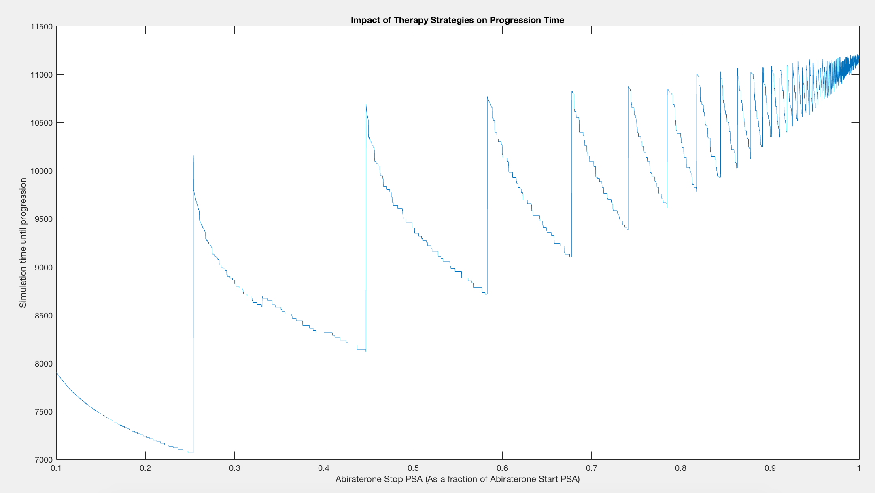

1. ***Need to make a proper Extended Data figure***
2. ***Need an accompanying Extended Data figure legend***

The adaptive cycle dynamics that results in the longest survival would be a flat line, that is no cycle at all. The model predicts that keeping PSA constant is the best possible outcome, though this may not be possible as if may require unreasonable small dosages and too much monitoring. But we should strive for this.

Have the clinic/pharma/compliance, tell us how close we can get to the optimal therapy. *This text seems like a stream of consciousness or notes rather than something that belongs in a Letter to Nature…*

**What PSA value to choose?**

***Again, these appear to be notes that have nothing to do with the manuscript***

What is the optimal PSA value? Oddly enough, the higher the better, this is because we allow the tumor to grow a lot. In this way there are a lot of TP and T+ when we start the cycles. The T- are always kept to a minimum when we start but it is best to have the most possible TP and T+. This equates to the highest tolerable PSA. Meaning we would have to convince people that it was a good idea to let their tumors grow so that we could keep them in check longer. Yikes. I think I like the idea of resetting the game with either chemo or testosterone. Maybe this will be more for the mathematics paper.

**Trial details**

*I. Patient Selection*

Candidates for the study included patients with ECOG 0-2 performance status (PFS), adequate organ function and who had started abiraterone acetate plus prednisone as standard of care for progressive (PSA or imaging progression) mCRPC. Patients could be enrolled in the study after achieving 50% or more decline of their pre-abiraterone PSA levels. This patient population is similar to the AA-302 population except allowing ECOG 2 PFS, prior exposure to enzalutamide, Sipuleucel-T, and ketoconazole [7]. Prior exposure to docetaxel was also allowed if it was given during the non-castration, pre mCRPC setting. Like the AA-302 trial, patients who took opioids for cancer-related pain were excluded.

*II. Study Design and Treatment*

This is a single institution investigator initiated pilot study funded by the Moffitt Cancer Center, Tampa, Florida. The protocol was approved by central IRB and monitored by Moffitt Cancer Center’s protocol monitoring committee. Each enrolled patient began on abiraterone (1000 mg by mouth daily; and prednisone) until achieving a > 50% decline in their baseline levels of PSA pre-abiraterone. Upon achieving this decline, abiraterone therapy was suspended.

Concomitantly and at the discretion of the investigator, patients would either stop prednisone or be tapered off prednisone. Patients were monitored every 4-weeks with a lab (CBC, COMP, LDH and PSA) and clinic visit. Every 12-weeks, each patient received a bone scan, and a computed tomography (CT) of the abdomen and pelvis. Abiraterone plus prednisone were reinitiated when a patient’s PSA increased to or above the pre-abiraterone PSA baseline. Abiraterone therapy was then again be stopped after the patient’s PSA declined to > 50% of his baseline PSA*.* Each successive peak of PSA when abiraterone therapy was reinstated was defined a complete cycle of adaptive therapy.

For patients who did not undergo surgical castration, GnRH analog treatment was continued to maintain castration levels of serum testosterone. Patients who did not achieve a 50% decline of their baseline PSA after restarting abiraterone remained on study until they develop radiographic progression while on abiraterone based on PCWG2 criteria [21]. (At the time of writing one patient fell into this category). Patients who developed radiographic progression while being off abiraterone would restart abiraterone and remain on abiraterone until partial response was noted in the measurable lesions and stable disease was noted in the non-measurable lesions in the repeat bone scan, and abdominal and pelvic CT. These subjects were then allowed to stop abiraterone and reenter the adaptive therapy cycles. Patients are followed until they develop radiographic progression or ECOG performance status deterioration while on abiraterone, whichever comes first .

*III. End Points*

At time of writing, there are 10 patients that have been on the trial sufficiently long to exhibit two complete cycles of adaptive therapy. The primary measurement endpoint was PSA response rate (defined as 50% decline of pre abiraterone PSA) after completing 2 cycles of adaptive therapy. The secondary endpoints were median radiographic progression survival while on Abiraterone and the median time to ECOG performance status deterioration. Radiographic progression-free survival was defined as freedom from death from any cause; freedom from progression in soft-tissue lesions as measured with CT, defined as “progressive disease” according to modified Response Evaluation Criteria in Solid Tumors (RECIST) criteria; or progression on bone scan according to PCWG2 criteria.

**Mathematical modeling**

The fitness function was set up as follows:

$$G_{i}=r_{i}\left(\frac{K_{i}-(1-E_{i}) \sum{x_{j}}}{K_{i}}\right)$$

where $\sum{x_{j}}=x_{1}+x_{2}+x_{3}$.

The population dynamics are a simple difference equation.

$$∆x_{i}=x_{i}G_{i}$$

The PSA dynamics are shown below.

$$\frac{dPSA}{dt}=f_{1} x_{1}+f_{2}{ x}_{2}+f_{3} x_{3}-σ_{PSA}∙PSA$$

where $σ_{PSA}=0.3$ and where $f_{i}$ is the PSA production per cell based on the frequency of TP cells.

In the pre-Lupron world

(***do we care about a pre-Lupron world – this is jargon –you mean pre-ADT, right?***)

In naïve tumours all three tumour cell types are producing their maximum amount of PSA per cell as systemic androgen is available. In this way T+ cells produce 1 PSA per cell and both TP and T- produce 4. ***(Sorry I don’t follow your logic)*** Following ADT, these functions are used to have PSA production be a direct byproduct of the androgen produced by the TP cells. When there are no TP cells, T+ cells make almost no PSA as there is no androgen, and increase PSA production up to the maximum of 1. ***(how, if PSA is an AR target gene?)*** TP and T- cells still produce 1 PSA per cell even in no-androgen environments and increase to 4 PSA per cell as TP frequency increases. ***Where do you get 4 PSA/cell, sorry I don’t get it***

**Explain that this is meant to also be qualitative from measurements in references.**

***This text needs work, very confusing***

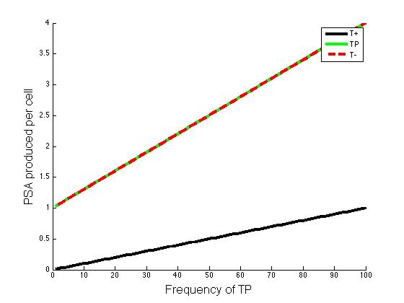

1. ***Need to make a proper Extended Data figure***
2. ***Need an accompanying Extended Data figure legend***

The growth rates and carrying capacities for the three different treatment situations are shown below.

**Pre - ADT**

|  |  |  |
| --- | --- | --- |
| T+ | TP | T- |
| $$X=0$$ |  |  |
| $$K_{1}=300$$ | $$K_{2}=200$$ | $$K_{3}=100$$ |
| $$r_{1}=0.005$$ | $$r_{2}=0.002$$ | $$r_{3}=0.001$$ |

**Post - ADT**

|  |  |  |
| --- | --- | --- |
| T+ | TP | T- |
| $$X=300$$ |  |  |
| $$K_{1}=p_{2}*X$$ | $$K_{2}=200$$ | $$K_{3}=200$$ |
| $$r_{1}=0.005$$ | $$r_{2}=0.002$$ | $$r_{3}=0.001$$ |

**Post – ADT with Abiraterone**

|  |  |  |
| --- | --- | --- |
| T+ | TP | T- |
| $$X=300$$ |  |  |
| $$K_{1}=p_{2}*X$$ | $$K_{2}=200*f_{ABI}$$ | $$K_{3}=200$$ |
| $$r_{1}=0.005$$ | $$r_{2}=0.002$$ | $$r_{3}=0.001$$ |

Abiraterone treatment is modeled by decreasing the carrying capacity exponentially of TP as we assume that TP cells are either killed or quiescent during Abiraterone treatment. In this way the carrying capacity of T+ is also decreased because of symbiosis. You will also see that the growth rate of all three types of cells is minimized during Abiraterone as this has been shown in the literature.

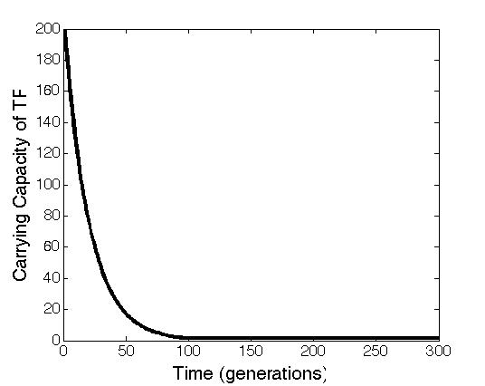

1. ***Need to make a proper Extended Data figure***
2. ***Need an accompanying Extended Data figure legend***